IoT & Automation Lab. Record

**Lab#1**

**Blinking the InBuilt LED**

void setup() {

pinMode(LED_BUILTIN, OUTPUT);

}

void loop() {

digitalWrite(LED_BUILTIN, HIGH);

delay(500);

digitalWrite(LED_BUILTIN, LOW);

delay(500);

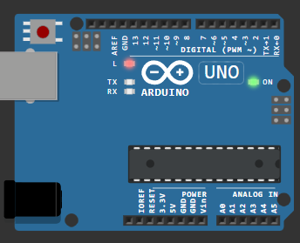}

[**Wokwi Link #1.0**](https://wokwi.com/projects/406490864427470849)

**Lab#2**

**Blinking an External LED ( Red ) w/ Resistor**

#define light 12

void setup() {

  pinMode(light, OUTPUT);

}

void loop() {

  digitalWrite(light, HIGH);

  delay(200);

  digitalWrite(light, LOW);

  delay(500);

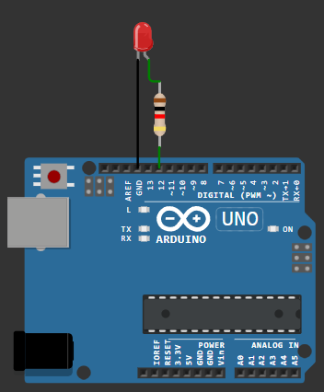  }

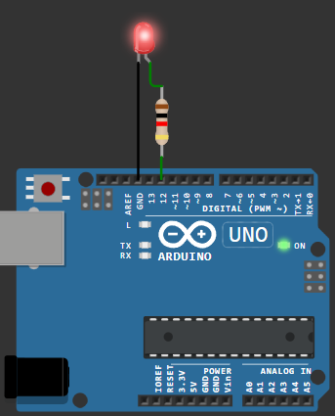

[**Wokwi Link #1**](https://wokwi.com/projects/406483824958897153)

**Lab#3**

**Using a Digital Humidity & Temperature Sensor**

#include <DHT.h>

#define light 7

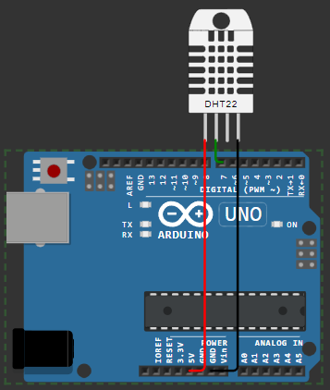#define DHTTYPE DHT22

DHT dht(light, DHTTYPE);

float humid, temp;

void setup() {

  Serial.begin(9600);

  dht.begin();

}

void loop() {

  delay(200);

  humid = dht.readHumidity();

  temp = dht.readTemperature();

  Serial.print("Humidity: ");

  Serial.print(humid);

  Serial.print(" %  Temperature: ");

  Serial.print(temp);

  Serial.println("°C");

  delay(1000);

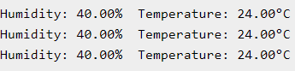}

[**Wokwi Link #2**](https://wokwi.com/projects/406487282785269761)